CHM 314
Lebanese American University
Experiment 4:
Reactions of Aldehydes and Ketones
Date: Wednesday, March 12th, 2013
Names: Hassan Sleem 201100854
Sarah Abou Alaiwi 201101690
Rana Asmar 201103655

- Objective:
- Perform common reactions for carbonyl group
- Test for the presence of a carbonyl group
- Detect the presence of aldehyde of ketone

- Procedure:
Refer to the manual pgs 231-243
- Reactions Involved:
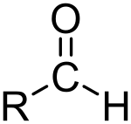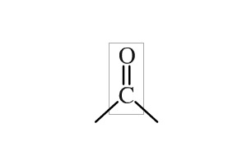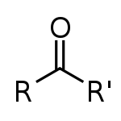
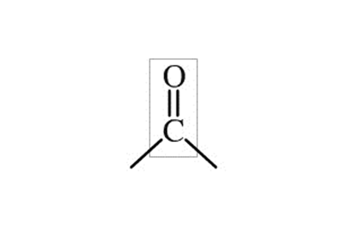
Aldehyde Carbonyl Ketone

- Tests to prove the presence of
- Oxime Test:
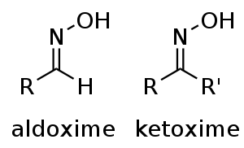
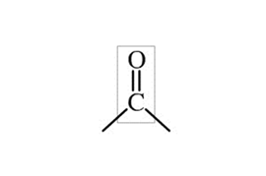

+ NH₂OH

Hydroxyl Amine Oxime
Result: This test gives was not performed in the lab.
- Phenyl Hydrazone Test

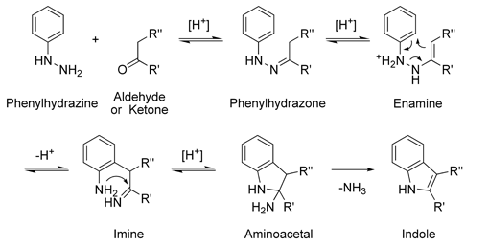
- In 2 test tubes, add 1ml of benzaldehyde in one, and 1ml Cyclopentanone
- Add 3ml phenyl hydrazine in each
- Shake well and observe

Result: Both test tubes gave us orange red precipitate

- 2,4-dinitrophenylhydrazone Test:

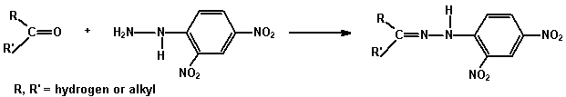
Result: Both benzylaldehyde and the cyclopentanone gave us orange yellow precipitates.

- Semicarbazones:
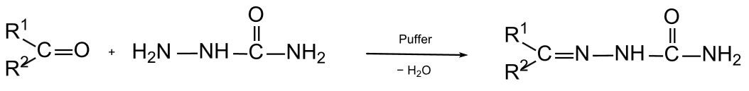
Semicarbazide Semicarbazone
This test was not performed in the lab.
1-Aldol Condensation
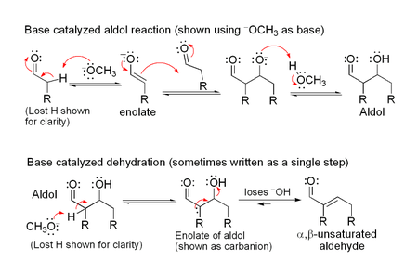
2-Crossed Aldol Condensation
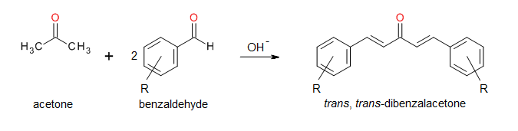

-2.5 ml Benz aldehyde + 1 ml acetone + 15 ml ethanol
- we add 5 ml NaOH 5%
-Swirl till solid appears
-Cool, Filter

- Special Tests for Aldehydes:
These tests show negative results for ketones.
- Tollen’s Test:
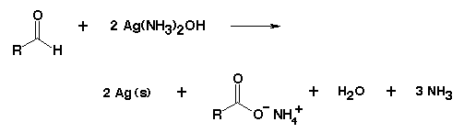
Tollen’s reagent (Silver diamine complex) is very explosive; it cannot be stored and must therefore be prepared in Situ.
Tollen’s Reagent Preparation:
To 2ml AgNO₃, add 1ml NaOH. Add NH₃ drop wise just to dissolve ppt.
Reactions:
2AgNO₃ + 2NaOH Ag₂O + 2NaNO₃ + H₂O
Ag₂O + 4NH₃ + 3H₂O 2Ag(NH₃)₂ + HO⁻
We did Tollen’s test for benzaldehyde and 3-pentanone each time adding a few drops of Tollen’s reagent to 3ml of the carbonyl compound and then heated in a warm water bath.
Benzaldehyde gave us a silver mirror (positive result) whereas 3-pentanone maintained the yellow (light brown) coloration (no change; negative result)
- Fehling’s Test:
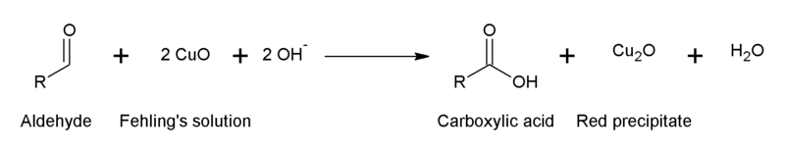
Do Fehling Test for acetaldehyde and 3-pentanone and then heat in a warm water bath.
Results:
Fehling test showed unusual results in the lab session probably because of inappropriate contaminations. In theory, it remains blue with 3-pentanone (ketone) and gives a brick red precipitate with acetaldehyde (aldehyde).
- Haloform Reaction (Iodoform test)
This is a test for α-methyl ketones.\
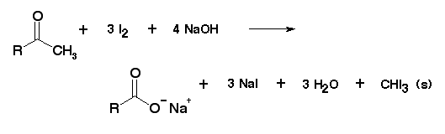
Iodoform (CHI₃) is a yellow precipitate.
P.S: It should be noted that I₂ is not soluble in water and therefore, we use IKI instead.
We add IKI to 5 drops of acetone (α-methyl ketone; (CH₃)₂CO) mixed with 2ml of 5% NaOH and shake. We observe a nice yellow precipitate at the end end.

- Table of Reagents
Reaction of benzaldehyde and acetone
Compound | Molecular Formula | Molecular Weight (g.mol⁻¹) | M.p (°C)
Benzaldehyde | C6H5CHO | 106.121 | -26°C°C
Acetone | C3H6O | 58.08 | -95°C
Dibenzalacetone | C17H14O | 234.29 | 60 °C

- Results:

Reagent Molecular Weight Grams Moles
Benzaldehyde 106.121 g.mol⁻¹ 2.5ml(d=1.04g/ml) 0.0245 mol
Acetone 58.08 g.mol⁻¹ 1ml (d=0.791g/ml) 0.0136 mol
The yield-limiting reagent is benzaldehyde (0.0245/2= 0.01225 < 0.0136 mol)
Theoretical yield of dibenzal acetone = 0.01225 mol = 0.01225 mol × 234.29 g.mol⁻¹ ₌ 2.87 g
Actual yield = 2.51 g
Percentage yield = $\frac{2.51}{2.87}×100=87.5 \%$
- Discussion of Results:
We obtained a percentage yield of 87.5% which is relatively good and is less than 100% due to several experimental errors discussed below.
- Sources of Error:
- The greatest source of error during the procedure arises from the fact that the reactants and products are transferred between containers multiple times.
- The presence of any contaminants in the glassware used.
- During the dryin grocess, some of the reactants remained stuck to the filter paper.

- Answers to questions

